**LEGO – The Chef Assistant**

**By**

**Dayananda Saraswathi, Ampapathina (16203705)**

**Sirish Chandra Madanapally (16190428)**

**Manohar Reddy Dyapa (16199984)**

**Ravisha, Thallapalli (16171645)**

**Motivation**

There is great saying “Health is wealth”. In order to stay healthy we need to take proper intake of food. Nowadays as people are getting busier and have no time for cooking and start eating outside which is not at all recommended and if they take time to cook, they start searching for recipes online and if that recipe has ingredients which are not available at home, they start searching for another which may end up in lots of time waste. To overcome such a situation here is an application, which can help people to cook in faster and easier way. The user can list out the ingredients, which he has at home, and the application will return a list of dishes that he can prepare with those ingredients.

**Significance**

The system takes input ingredients from the users in the form of speech or text and displays the list of recipe’s possible using those ingredients. The main feature of our Romo designed is that you can train the Romo to identify a person according to his favorites and it identifies and displays the recommended recipes for that particular person.

**Objectives**

The main objective of the application is to ease the process of cooking. Instead of searching recipe we provide the ingredients and we will obtain the dish, which can be prepared from the given ingredients.

**Related Work**

We have various recipe applications, which give us recipe list given the recipe name, and then we get to know the ingredients needed for the recipe but if suppose we do not have the ingredients available at home, then we need to search for another recipe. And if we do not have the ingredients for the other recipe too, we have to again search for a new recipe.

To overcome this scenario we developed an application which list the recipes according to the available ingredients or if we wanted to make a recipe which the ingredients which we have at home. The recipe also gives us the steps for the recipe preparation.

**System Architecture**

Our application architecture is as follows, in our application user can give the input either through the android device or from the I-OS device. The input given is taken by the application and gives the required output. The application uses API for certain services like the weather service, nutrition calculation, Google speech to text and recipe preparation steps. Our application also gives recommendations based on face recognition. According to the trained data as input where the user gives certain favorites. Recommendations are given based on it.

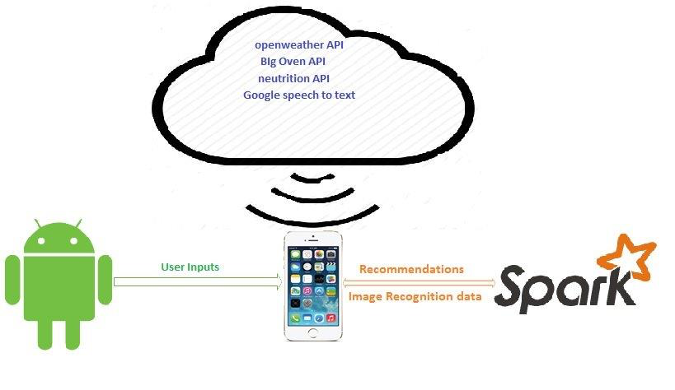

**System Features**

The application developed works with the help of the bot ROMO, which acts as cooking guide to the user, based on the ingredients, provided by the user.

The bot uses the IPhone as sensor to learn about the user input. And processes the data accordingly and retrieves the recipes.

**System Requirements**

In order to use the application we would need

Mac Machine (For development activity)

IPhone (5 and above generations for application installation)

ROMO (bot which takes the user input with the help of the IPhone)

**Implementation**

“The LEGO kitchen Assistant” is an IPhone based application for ROMO, is designed to give food recommendations for the user based on their interests and suggest the user recipes for making the food. We have implemented this by combining the image analysis and the BigOven API. First we have to train the system with the user’s face. We have created a dataset for storing the person’s interests in the application, these can be updated according to the person’s interests. So, when user opens image recognition, it identifies the person by analyzing his face. Once the user is identified, we are using the API services from BIG Oven, and retrieving the data by sending his interests in the API request. User can select his choice of food, once he selects the food, it displays the recipe to make the food.

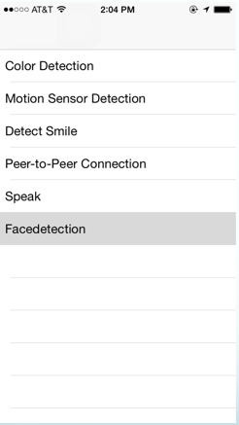 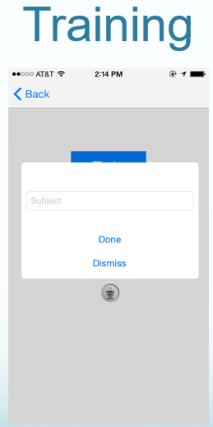

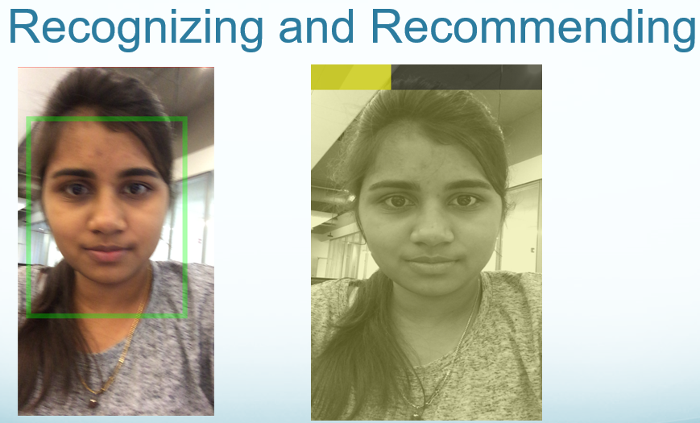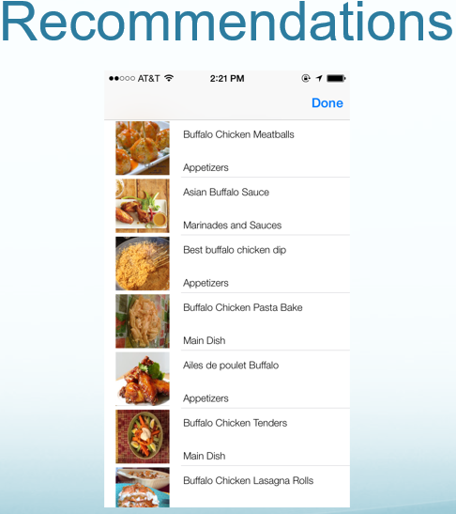

**Spark**

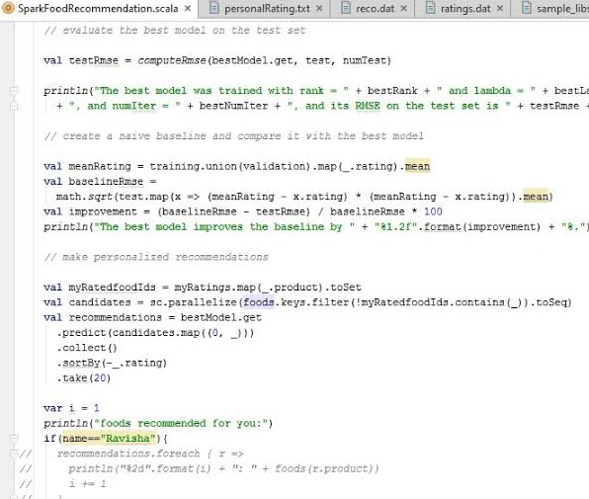 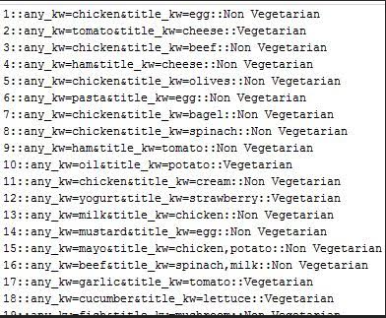

We are using the nutrition API to get the details of nutrition values like calories, fat etc. of the food item, by sending the name of the food in its API request, and we are displaying the data on the application. User can check the nutrition values by using the Google’s speech to text service that was integrated to the application. User can also get the weather updates, by specifying the location name, or zip code or longitude and latitude of the location, in their voice inputs like “Weather Kansas city”. Google’s speech to text service converts this voice commands to text and sends it to the application. We are using OpenWeather API to get the weather details, and displaying the results.

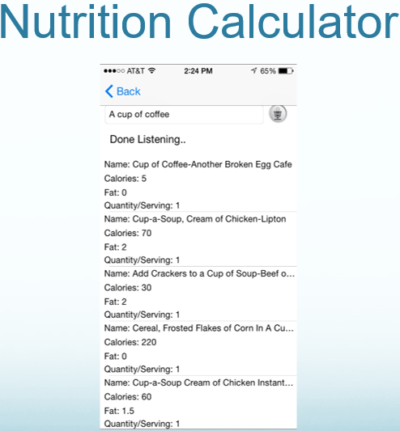 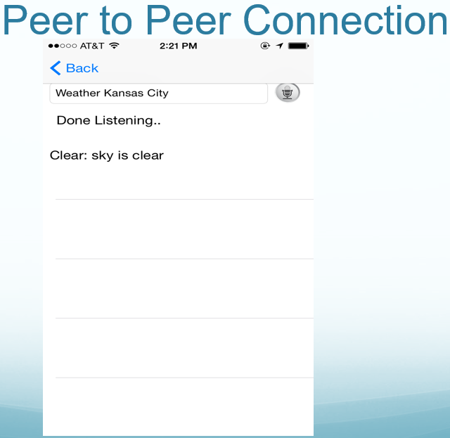

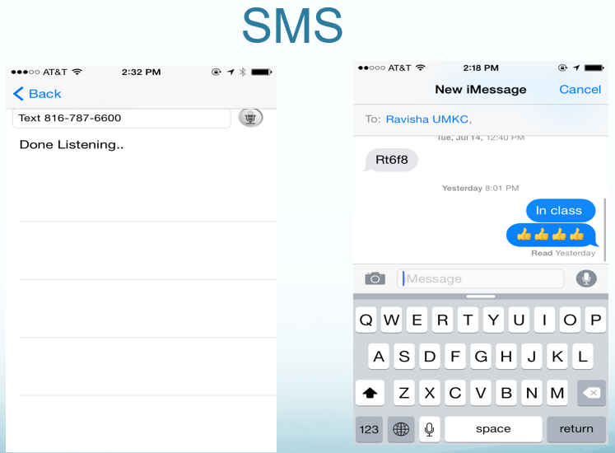 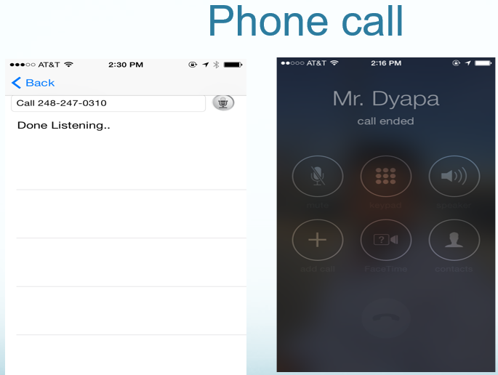

With the help of peer to peer connection, user can operate ROMO, like moving around, and contacting a person from an android device by sending commands, to the application. ROMO can perform colors detection by using the secondary camera of the I-Phone, motion sensor detection, basic idea behind color detection is to identify the traffic signals and, to adjust its speed depending on the platform slope. We implemented emotion detection feature for the ROMO. ROMO detects person’s face and if the person smiles the ROMO identifies the emotion and it also smiles.

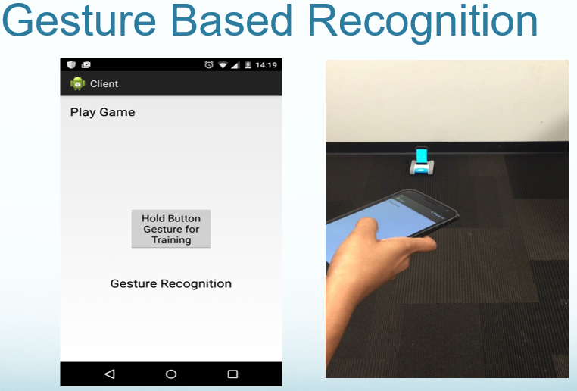

**Results**

The LEGO, kitchen assistance, works provides perfect food recommendations and recipes to prepare the food for a person based on his interests. It also provides the nutrition values of the food.it also provides weather updates, by using the API services from the “The Logo” application. Users can call and text a person by providing the name from the contact list or by giving the number or send the commands from any android device using peer to peer connection.

**Conclusion**

The project work gave us a good opportunity to explore various big data and machine learning technologies. It also gave us an opportunity to interact with romo. The project can be continued further adding little more complexities, integrating with few more existing applications and third party API’s.

**Future work**

As part of future work we planned to upgrade the food recommendations according to time of the day, and location based restaurant suggestions and integrating it with the spark to get the recommendations based on the user’s interests. We are also planned to integrate the other third party application services related to food recipes.

**Bibliography**

<http://www.ibm.com/smarterplanet/us/en/cognitivecooking/tech.html>

<http://romotive.myshopify.com/products/romo-the-smartphone-robot>

Video Demo: <http://youtu.be/hE-g06j4zW4>

GitHub: <https://github.com/mdgg7/BigDataProjectFinal.git>